**Advance Excel Assignment 9**

|  |
| --- |
|  |
|  |  |

1. What are the different margins options and do we adjust the margins of the excel worksheet?

To use predefined margins, click **Normal, Wide, or Narrow**. Tip: If you previously used a custom margin setting, that setting is available as the Last Custom Setting option. To specify custom page margins, click Custom Margins and then—in the Top, Bottom, Left, and Right boxes—enter the margin sizes that you want.

1. Set a background for your table created.

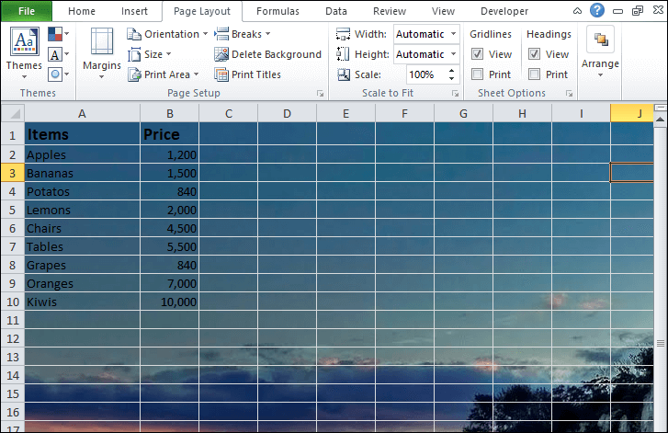

1. What is freeze panes and why do we use freeze panes? Give examples.

The Excel Freeze Panes option **allows you to lock your columns and/or rows so that when you scroll down or over to view the rest of your sheet, the column and/or row will remain on the screen**.

1. What are the different features available within the Freeze Panes command?

**If you apply the Freeze Pane option of Excel freeze pane feature, it can freeze the row and column simultaneously at the same time.**

* Freeze pane. ...
* Freeze Top row. ...
* Freeze First column.

1. Explain what the different sheet options present in excel are and what they do?

It **allows us to organize vast amounts of data across multiple sheets**. Every Excel workbook has at least one sheet. By default, when we create a new Excel file, it usually has three sheets, namely Sheet1, Sheet2, and Sheet3. Furthermore, we can add or delete the desired number of sheets accordingly.